Week 3

Exercise 1

Exercise 1

Solution: 93P = 50p + 2 \* 20p+ 2p+ 1p

So 5 coins in total

Exercise 2

1. Check if the number is bigger then any of our coins available

2. Take the biggest of the coins that is less than our value

3. Subtract it as many times we can so that our number still remains a positive value and the amount we manged to subtract it gets added to the total value of coins

4. If the number becomes negative we move down a coin value and see if we can subtract it. If we can we add it to the total number of coins

5. We do step 4 until it becomes 0 and add the amount of coins we subtracted and we get the total result

Exercise 3



It’s the same as my answer 😊

Exercise 4

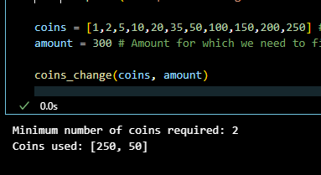

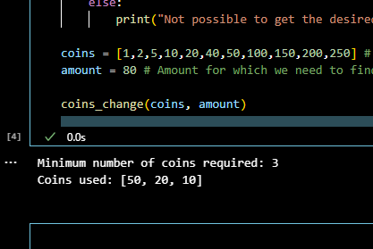

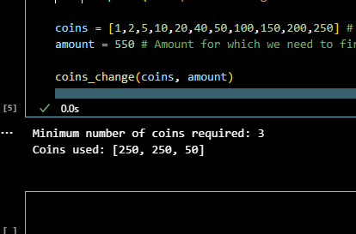

Exercise 5

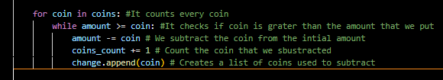

Exercise 6

Would be more efficient if the code will be able to subtract the coin 80 more efficiently, I don't know why it comes up with the answer 50, 20, 10. Even if I added a new 40 coin

I will be better by adding error handling that verifies if the amount that is given is negative and it outputs a message.

Exercise 7

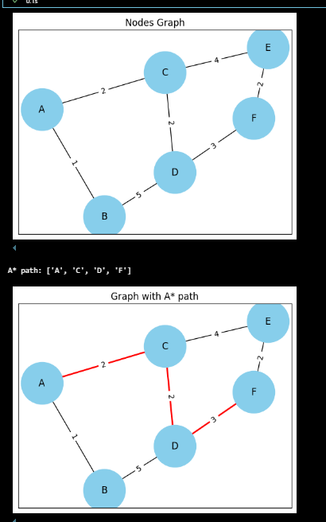

Exercise 8.

Exercise 9: